**Learn in Community**

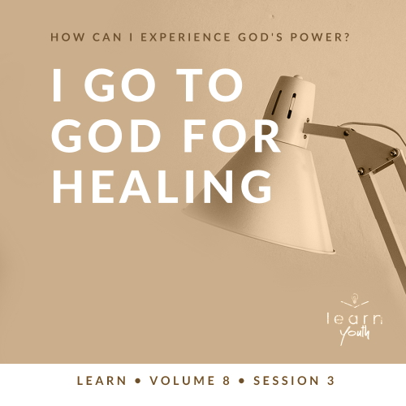

Small Group Study



**Volume Overview**

**How can I experience God’s power?**

“I tell you the truth, anyone who believes in me will do the same works I have done, and even greater works, because I am going to be with the Father.” ([John 14:12](https://ref.ly/logosref/Bible.Jn14.12))

*For this volume, we’ll focus on God’s power. More specifically, we’ll ask and address the question: How can I experience God’s power in my life? Even a skim through the Bible reveals that God expresses His power in many ways. From Genesis to Revelation, the entire Bible is filled with accounts of impossible things becoming possible with God. And God’s power continues in believers’ lives today. We can experience miracles, have bold faith, believe for healing, and know God answers our prayers.*

|  |
| --- |
| ***You Will Need***  *• Seven white hand or dish towels*  *• Seven small containers of water, large enough to dip the towel into*  *• Seven different cleaning products (dishwashing liquid, hand soap, laundry detergent, etc.)*  *• Dry towels*  *• Two tables*  *• Timer (e.g., smartphone, clock, stopwatch)*  *• Optional: Tarp to keep the floor dry*  ***Getting Ready***  *• Before the session, dirty all the towels equally using a combination of dirt, mud, grease, paint, or any other item that can be cleaned off.*  *• If desired, test clean one of the soiled towels to have an idea of how long it will take to clean.*  *• Set up the game before the students arrive.*  *• First time leading* Learn *for Youth? Look here for the* [Facilitator Guide](https://0b769b0ed3569ef9d18b-f88d8272f61086866d50d048b43ef630.ssl.cf2.rackcdn.com/sites/biblengagementproject/Listen_Facilitator_Guide.pdf)*.* |

To access session content and videos from a computer, visit: [BibleEngagementProject.com/downloads](https://bibleengagementproject.com/downloads)

**Engage**

**Welcome**

*Take this time to welcome everyone, introduce new students, learn names, and thank everyone for coming. Your friendliness here can create comfort levels that encourage student participation later.*

|  |
| --- |
| **QUESTION**  Which do you think is the cleanest: rivers, lakes, or oceans? |

|  |
| --- |
| **QUESTION**  Which of these would you choose to spend the day swimming in? |

**Opening Prayer**

*Prayer thoughts: Thank the Lord for bringing everyone together. Pray that His power and strength would be shown in each life. Ask Him to also prepare everyone’s heart to believe for healing for themselves and others in their life.*

**Introduction**

The Bible makes it clear that God is far more than capable of healing people. This should bring us great joy and hope. Today, we’ll look at one of the many times in the Bible God healed someone and what we can learn from that. As we look at this account, we’ll work through some difficult questions and hopefully get a healthy perspective on healing. At some point for each of us, we likely will need to experience God’s power for a healing miracle. In this session, we’ll look at the process behind healing and our role in it. But first, let’s try an activity that’s related to the story we’ll read later.

**Group Activity**

**Dip, Baby, Dip**

|  |
| --- |
| ***You Will Need***  *• Seven white hand or dish towels*  *• Seven small containers of water, large enough to dip the towel into*  *• Seven different cleaning products (dishwashing liquid, hand soap, laundry detergent, etc.)*  *• Dry towels*  *• Two tables*  *• Timer (e.g., smartphone, clock, stopwatch)*  *• Optional: Tarp to keep the floor dry*  ***Getting Ready***  *• Before the session, dirty all the towels equally using a combination of dirt, mud, grease, paint, or any other item that can be cleaned off.*  *• If desired, test clean one of the soiled towels to have an idea of how long it will take to clean.*  *• Set up the game before the students arrive.* |

This game is simple, and it’s all about cleaning. Raise your hand if you like to clean. *(Group response)*

|  |
| --- |
| **QUESTION**  What’s the hardest thing you’ve ever had to clean? |

We need seven volunteers. Each one will have a very dirty towel, a cleaning product, and a small container of water. When I say, “Go,” you’ll take your towel, apply the cleaner, and dip the towel into the water. The objective is to get your towel as clean as possible. You can do whatever you need to do to get the towel clean. At the end of the allotted time, we’ll judge whose towel is the cleanest.

• *Choose the volunteers. Caution students to use only one cleaner on their towel as mixing chemicals could be dangerous.*

• *Set the timer.*

• *Option: Allow students to work until someone’s towel is clean and then compare with the others.*

• *When the time is up, determine who won the challenge or give them another minute to compete if needed.*

You did a great job trying to get the towels clean. We’re going to read a story from the Old Testament when an individual experienced God’s healing through washing in water. But, it’s a story about much more than simply being cleaned up. First, let’s watch the video.

**Watch**

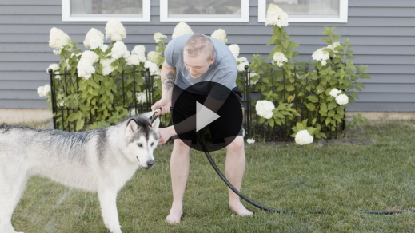

**Consider What the Bible Says**

*Ensure each student has access to a Bible, preferably the same version.*

We’re going to look at the life of Elisha again. This time we’ll look at his part in the miraculous healing of a man named Naaman. Let’s find out what God did.

**God Can Use Others in Your Healing**

Read [2 Kings 5:1–3](https://ref.ly/logosref/Bible.2Ki5.1-3).

These verses begin with a respected leader who was in a bad situation. Though he was successful in his work, he had been unsuccessful in avoiding a contagious skin disease. Like him, there are things we can do to take care of ourself in life and things that we need help to overcome.

|  |
| --- |
| **QUESTION**  What role did the young girl play in Naaman’s healing? |

Being from Israel, the girl knew about God and His healing power. She also understood at this point in history how God often used prophets in His miracles. Her encouragement for Naaman to seek God’s prophet was a crucial part of the healing process. We can also help others find their way to God so they can experience His healing power. Though the Bible doesn’t tell us this young girl’s name, there’s a lot to learn from her important part in an impressive healing testimony.

|  |
| --- |
| **QUESTION**  Have you ever believed for someone’s healing? What did you do, and what happened? |

|  |
| --- |
| **QUESTION**  Do you think it’s easier to believe for someone else’s healing or your own? Why? |

**Did You Know?**

|  |
| --- |
| The Hebrew word used to describe the physical problem Naaman faced is *tsara*. This word was used in Old Testament times to describe various skin diseases and issues, including leprosy. So, it’s uncertain if Naaman had the disease called leprosy today or a different skin issue because his symptoms are not described in detail. What we do know is that his disease was bad enough to compel his king to send one of his great commanders to another land and before a foreign king for help. |

**The Path to Healing Often Includes Accepting Reality and Bold Faith**

Read [2 Kings 5:4–8](https://ref.ly/logosref/Bible.2Ki5.4-8).

With his king’s blessing, Naaman traveled to Israel in the hope that he would be healed from his incurable disease.

|  |
| --- |
| **QUESTION**  Why do you think it was important for Naaman to choose to leave his homeland and travel to Israel to seek healing? |

The young girl believed that the prophet could heal Naaman. After all, the prophet had a relationship with the healing God. But that prophet simply wasn’t in Naaman’s current location. So, Naaman went to the necessary place to connect with the servant of God who could help with his healing.

|  |
| --- |
| **QUESTION**  What might this Bible story say about the change we may need to make when looking for God’s healing? |

It’s not that God can’t heal someone anywhere. Later in this story, we’ll see that the prophet didn’t even need to see or touch Naaman for God’s healing to happen. The point is that we go to God for healing. And sometimes in our pursuit of closeness with Him, we may find that we need to make changes in our life.

|  |
| --- |
| **QUESTION**  What are some things we can do to help others be positioned to receive God’s healing? |

|  |
| --- |
| **QUESTION**  Have you ever been asked to pray for someone’s healing? |

|  |
| --- |
| **QUESTION**  If not, would you be willing to pray for someone to be healed? Why or why not? |

**Healing Doesn’t Always Happen When or How You Expect**

Read [2 Kings 5:9–14](https://ref.ly/logosref/Bible.2Ki5.9-14).

Now, we’ve reached the part of the story in which Naaman was healed. Before being healed, however, Naaman had to overcome his expectations for how he would be healed.

|  |
| --- |
| **QUESTION**  Why do you think Naaman became angry? |

|  |
| --- |
| **QUESTION**  Why was the advice of Naaman’s officers so good? |

|  |
| --- |
| **QUESTION**  Why do you think Elisha had Naaman dip in the Jordan River in order to be healed? |

It’s possible that Naaman had some pride in his life that God wanted to address. While we can’t know for sure, it’s clear that God’s process resulted in what was best for Naaman. The same can be true for us. Sometimes God works in creative ways to help us grow.

|  |
| --- |
| **QUESTION**  What might this say about God’s desire to heal more than just our physical needs? |

God cares that we’re whole. He cares for our emotions, character, and mental health as much as our physical health.

|  |
| --- |
| **QUESTION**  Why do you think God cares about more than just our physical health? |

|  |
| --- |
| **QUESTION**  Have any of you ever witnessed a healing miracle or know someone who has experienced physical healing? Share about that experience. |

**Reflect**

**I Believe God Can Heal**

Physical healing is a miraculous occurrence that we can’t control. But we can exercise bold faith, take steps of obedience, and even help others position themselves for healing. However, healing starts with believing wholeheartedly that God can and does heal those who are sick. When we believe this truth, it can change how we see the world. When we’re facing physical problems, we can rely confidently on the God who healed Naaman and still heals today.

Let’s pause and listen to what God might want to say to us about what we have read and shared. Answering the following questions is completely voluntary. These questions are meant to serve as a conversation between you and God. However, you may want to share your response with the group, but no one should feel obligated.

• *Pause for a few moments of silent reflection before asking students if they want to share.*

|  |
| --- |
| **QUESTION**  Do you truly believe that God can and does heal today? Why or why not? |

|  |
| --- |
| **QUESTION**  Is there anyone here in need of physical healing or wholeness in your life, and you’re ready to believe that God will heal you? |

**Activate**

If we believe in healing, we must put that faith into action. Let’s take a moment and pray for those here with us who need God’s healing power. Who would like us to pray for their healing?

• *Pray for those who indicated they would like prayer for healing. Consider having them share with the group and then having everyone pray for them. If you have a large group, break up into smaller groups to pray for those needing healing.*

|  |
| --- |
| **Salvation Opportunity**  *Include this if you think there may be some in the group who do not have a personal relationship with Jesus.*  We not only believe God can heal physically, we also believe He can heal our life for all eternity. The greatest healing God performs is when He heals us of our sin.  **Is there anyone here that we can pray for who doesn’t have a relationship with Jesus or wants to renew their relationship with Him?**  *Take a moment to acknowledge those who respond, and thank them for their desire to make things right between themselves and God. Pray with them as you close in prayer or after the group time is over. Following group time, talk more about where they are in their walk with God and how you might be able to help.* |

**Prayer**

Father, we confidently declare that You are Healer. We praise You for all the times through the years that You have miraculously healed someone. We believe not only that You can heal, but that You want to allow us to be a part of the healing process. Increase our faith to believe for miracles through the power of Your Holy Spirit. We ask for those in our church and families who need healing that You will provide for them. In Jesus’ name we pray. Amen.

**Conclusion**

God is Healer! We need to celebrate this truth and live every day with this hope. We cannot control healing miracles, and we cannot guarantee them. Let’s be people who minister to the sick and hurting. Let’s be available, so God can use us to do His miraculous works. Let’s have bold faith for healing.

Remember to engage with your devotions this week. As you discipline yourself to study the Bible, your faith will be strengthened.